How you can donate and help
The Tumaini Fund USA seeks to provide help to hundreds of thousands of children in Tanzania, one of the poorest countries in Africa. Your donation, small or large, will make a significant difference to "our" children's lives.

ways you can donate

In

Person
CONTACT US
Please contact Tumaini Fund USA and we can arrange a meet and greet.

ONLINE
donate here
Please click the DONATE
HERE button above or school below to make a donation today.

BY

EMAIL
CONTACT US
Please contact Tumaini Fund by E-mail to make donation arrangements.

Donate today

mosquito net

$10

One mosquito net distribution and training to protect a child from a needless, preventable death from malaria.

Solar Lamp
$16
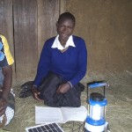

daftari Notebook

$10

One set of 10 daftari notebooks which is necessary for a child to attend school for one year.

ONE TIME

DONATION

$50
Every contribution to the Tumaini Fund USA makes a positive impact in the lives of the villagers we serve. Show your support with a one time contribution of $50.
A solar lamp provides light
to study by in a house
with no electricity.

Bicycle
$125
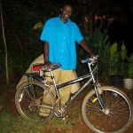
A bicycle can change the life of a child by providing transportation to far-away schools and to fresh water.

Build a
Firebrick Home
$2800
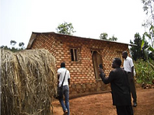
Provides a family with a new home; built of a mud brick wall, tin roof, and wood framed windows, shutters, and doors.

ToYOTA hILUX TRUCK
$23,000
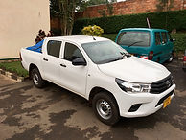
Provides Tumaini Fund volunteers the ability to transport material and personal.

Sponsor a family

$500
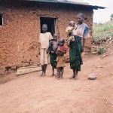
Sponsor a family of 5 for one year providing food, clothing, shelter and support of Tumaini Fund.

Motorcycle
$3200
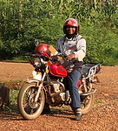
Provides social workers the ability to commute over large distances.

Gift in memory
Honor the memory of a loved one with a Gift in Memory to the Tumaini Fund USA. Let their memory help provide a better life for a child. Be sure to provide the name of recognized individual as well as the name and address of the person to whom the acknowledgement letter should be sent at PayPal checkout.
Donate

Elementary Student Sponsor

$25

Provide two sets of clothes, access to elementary school, school uniforms, books, pens and pencils, a mosquito net, and the support of our Parish workers available to them 24/7.

Secondary Student Sponsor

$100

Provides a year of secondary school for an orphan;
includes school uniform, books & supplies and
school fees.

Open donation
Every contribution to the Tumaini Fund USA makes a positive impact in the lives of the villagers we serve. Please select your own one time contribution amount or make it a reoccurring donation.

Sponsor Clean Water well
$3000
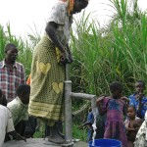
Provides a village with a clean water well.

Gift in honor
Honor someone with a Gift to the Tumaini Fund USA. Your contribution in their name will help make a significant difference in the lives of many. Be sure to provide name and address of Honoree at PayPal checkout.
Donate

Gift in celebration
Looking for a unique gift to celebrate a birthday, accomplishment or another occasion? Make a donation in celebration of a loved one and give them something meaningful that will make a difference. Be sure to provide the occasion as well as the name and address of the gift recipient at PayPal checkout.
Donate
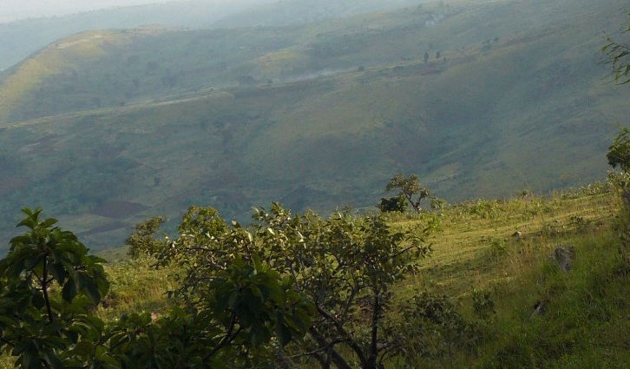

"Whatever you did for one of the least of these brothers of mine, you did for me. "

-jesus-

